1. Agenda:
   1. Discussion on Kafka Topic CLI 🡺 kafka-topics.sh.
2. We have a kafka cluster which is made of topics.  
   We will do topic management using Kafka Topic CLI.
3. A screenshot of a computer

   Description automatically generated
4. In this lecture, we will see how to use kafka-topics.sh cli
   1. To Create.
   2. To Delete
   3. To List a topic.
5. We will do these topic operations on our localhost as well as on ConduKtor cluster to see the things visually and it will also show how to connect to a secure cluster which is something that you will have to do most likely in some point of time in our Kafka Journey.  
   But the instructions are same for local and Conduktor platforms.
6. We can get the code from here <https://www.conduktor.io/apache-kafka-for-beginners/>
7. A screenshot of a computer

   Description automatically generated
8. Let’s create a configuration file   
   A screenshot of a computer

   Description automatically generated
9. A screen shot of a computer

   Description automatically generated  
   The above is secure connection.
10. Let’s do the same topic creation on our local system.  
    A white background with black text

    Description automatically generated
11. A screenshot of a computer code

    Description automatically generated
12. A screenshot of a computer

    Description automatically generated
13. There is another option called replication factor.  
    Replication factor is a way to replicate a topic on to multiple servers for disaster recovery and high availability.  
    But we can not have replication factory higher than the number of brokers we have in our cluster.  
    If still we try to create, we will get an error.  
    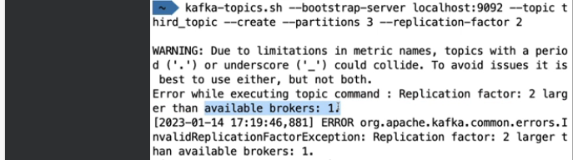  
      
      
      
    --replication-factor  
    A close up of a text

    Description automatically generated
14. --list  
    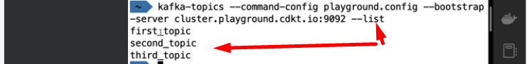
15. --describe A close up of a text

    Description automatically generated  
    Notice in the above slide that total 9 brokers have been used (3Partition\*3Replica=9=total replicas) to distribute our 9 replicas onto different brokers which is really, really nice.
16. --delete  
    